EMPLOYEE ONBOARDING SYSTEM
STEP 1: Open Service Catalog Items
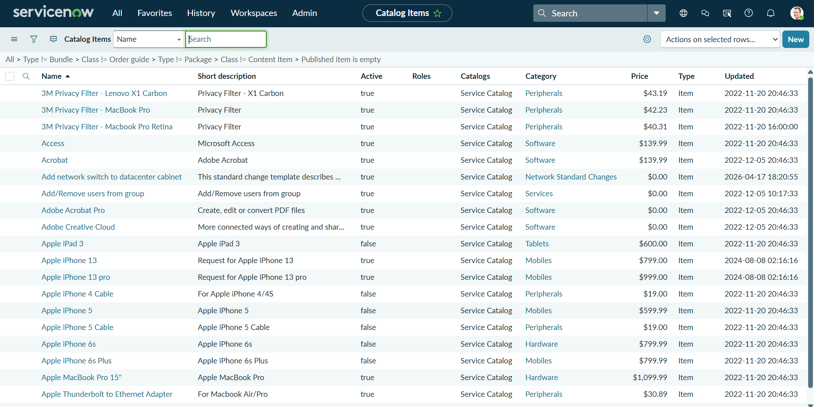
STEP 2: Create Your Project Form
STEP 3: Re-open Your Item
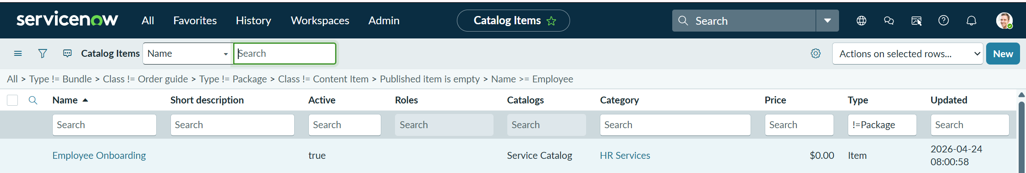
STEP 4: Add Form Fields (Variables)
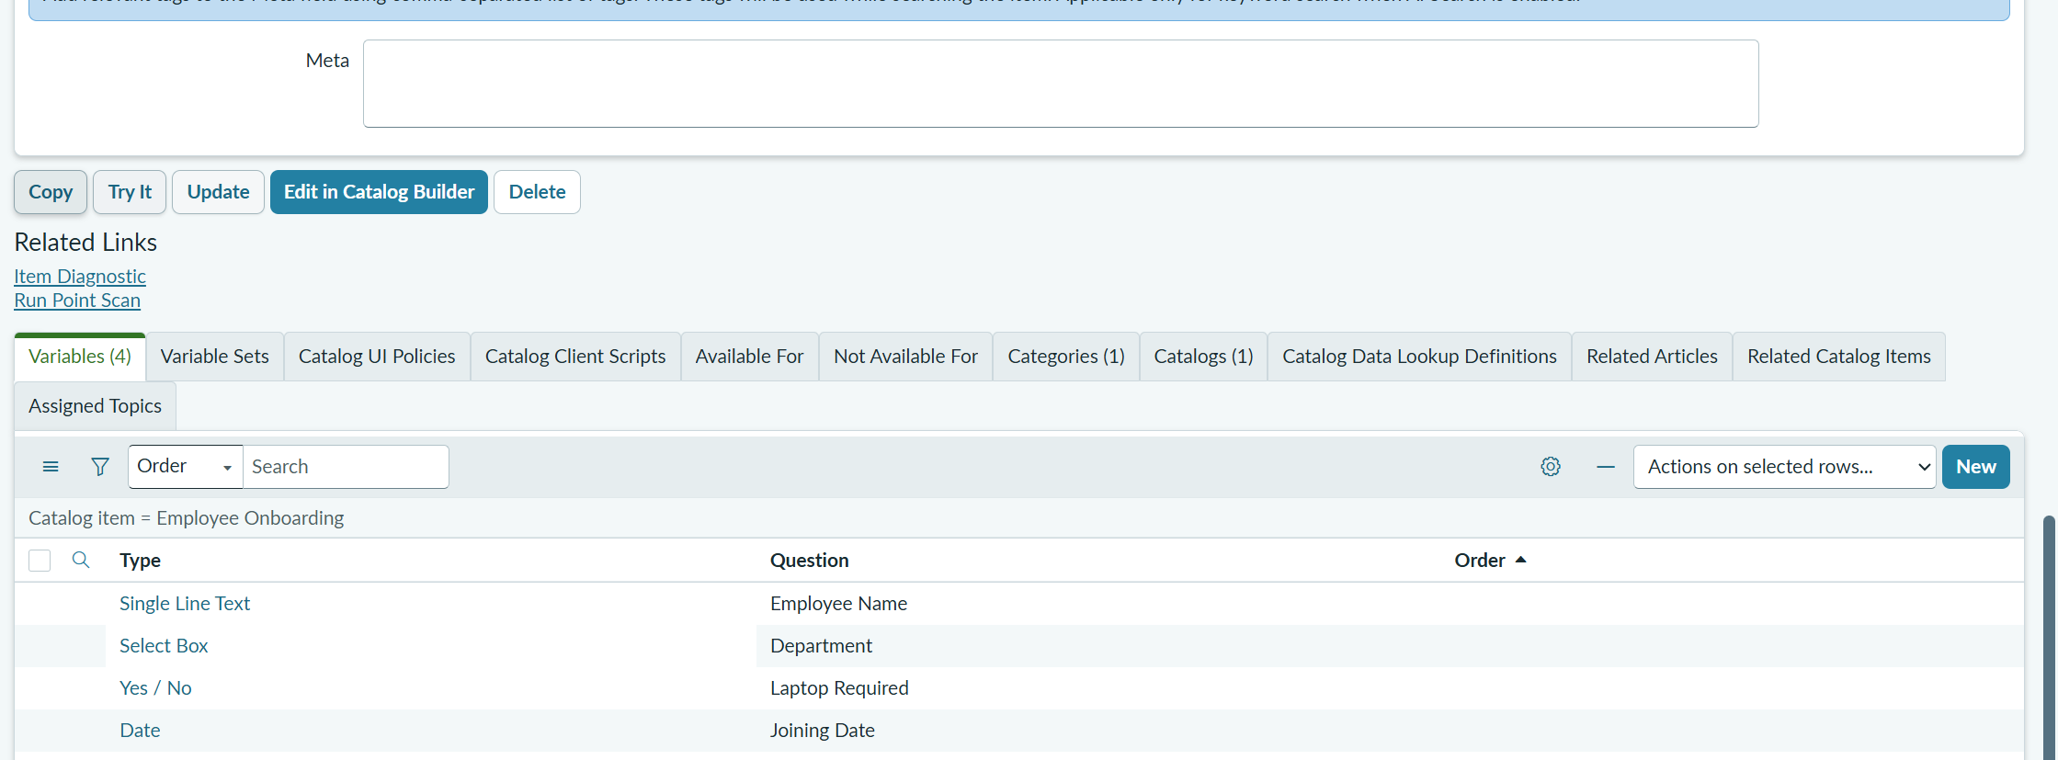

STEP 5: Create Automation (Flow Designer)
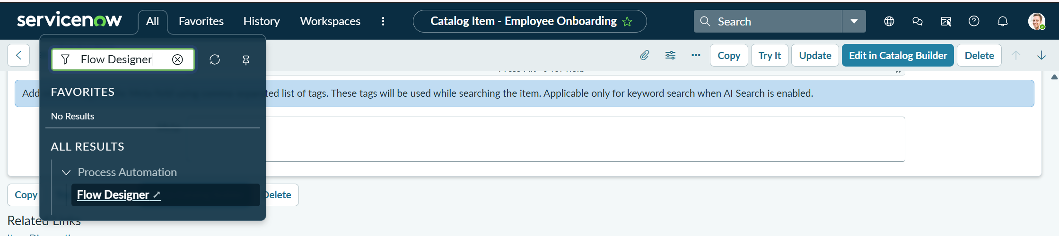
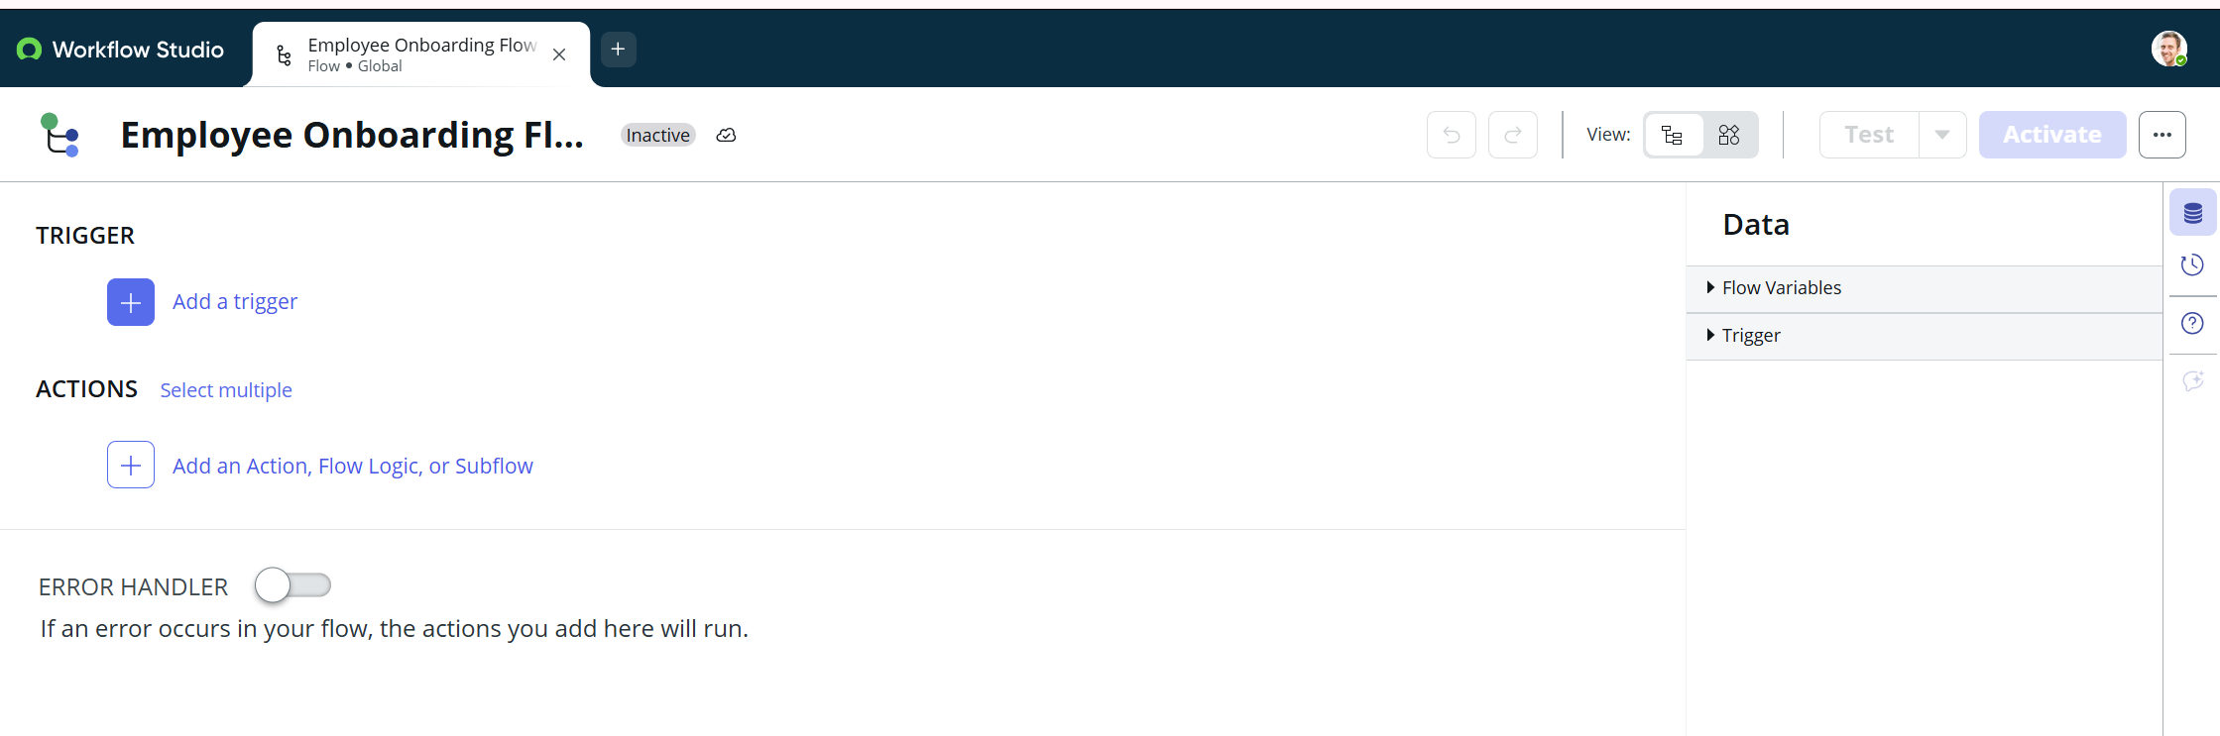
STEP 6: Add Trigger (WHEN it should run)
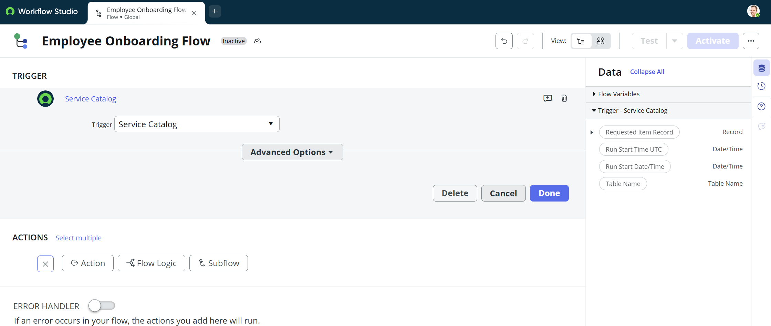
STEP 7: Add Approval
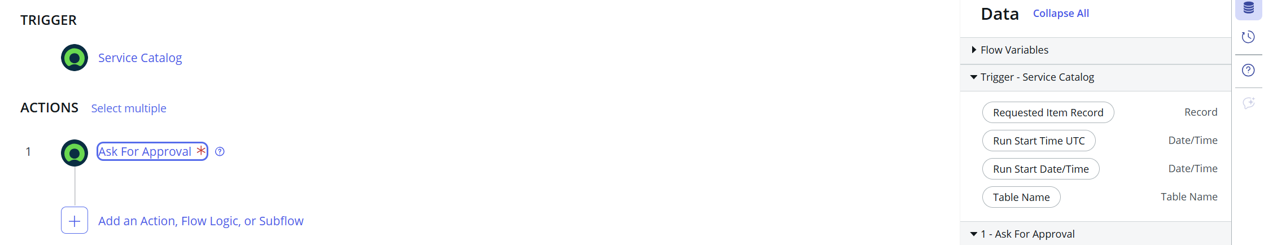
STEP 8: Create Tasks

